

Promotional Examination 2 2010

Pre-university 2

H1 CHEMISTRY 8872
PAPER 2 8872 / 2

16 September 2010 (Thur) 2 h

Additional materials:
Answer booklet
Cover page
Data Booklet
5 pieces of writing paper

READ THESE INSTRUCTIONS FIRST

Do not open this booklet until you are told to do so.
Write your name, index number and class on all the work you hand in.
Write in dark blue or black pen on both sides of the writing paper.
You may use a soft pencil for any diagrams, graphs or rough working.
Do not use staples, paper clips, highlighters, glue or correction fluids.

Section A
Answer all questions.

Section B
Answer any two questions on the writing papers. Start each new question on a fresh sheet of writing paper.

At the end of the examination, hand in your answers to Section A and Section B separately.
Attach the cover page to your answer scripts for Section B.

The number of marks is given in brackets [ ] at the end of each question or part question.

FOR EXAMINER’S USE
Section | A |  |  |  | B (2 questions) |  |  | Total
Section | Q1 | Q2 | Q3 | Q4 | Q5 | Q6 | Q7
Marks | 13 | 7 | 9 | 11 | 20 | 20 | 20 | 80

SECTION A (40 MARKS)

Answer all questions in the space provided.

1 | Oxides of nitrogen is a generic term for the mono-nitrogen oxides NO and NO₂. They are produced during combustion, especially at high temperatures.  At ambient temperatures, the oxygen and nitrogen gases in air will not react with each other. In an internal combustion engine, combustion of a mixture of air and fuel produces combustion temperatures high enough to drive endothermic reactions between atmospheric nitrogen and oxygen in the flame, yielding various oxides of nitrogen.  In a car engine, it was found that a mixture of nitrogen dioxide and carbon monoxide which was initially in the ratio of 1: 2 will reach dynamic equilibrium when 25% of the carbon monoxide has reacted.  NO₂(g) + CO(g) NO(g) + CO₂(g)  In areas of high motor vehicle traffic, such as in large cities, the amount of nitrogen oxides emitted into the atmosphere as air pollution can be quite significant.  To help reduce the amount of oxides of nitrogen in the environment, scientists came up with several methods as named in the graph below.  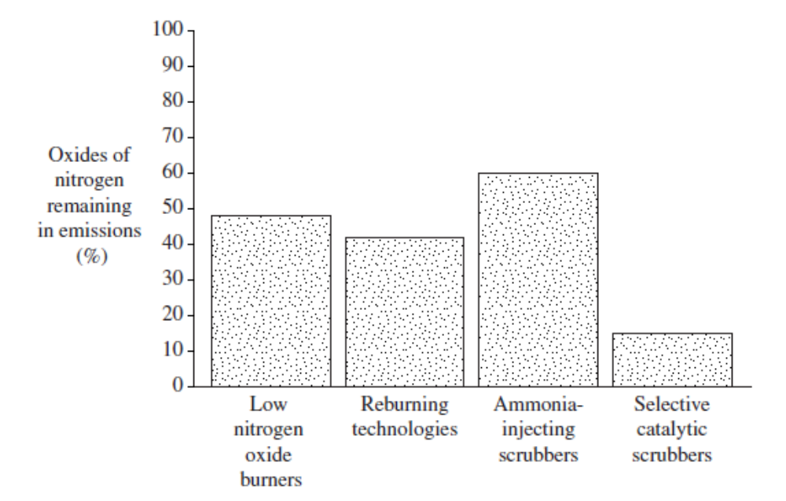
 | (i) |  |  | Draw the dot and cross diagram for the compound NO. | [1]
 | (ii) |  |  | Draw a well labeled energy profile diagram to illustrate the reaction between nitrogen and oxygen in order to produce nitrogen oxide. | [2]
Correct shape with axes – 1 mark.
Labeled diagram( N₂, O₂, NO, CO₂) – 1 mark.
 | (iii) |  |  | What do you understand by the term dynamic equilibrium? | [1]
 |  |  |  | Dynamic equilibrium refers to a state of balance in a reversible reaction or process in which the rates of the forward and reverse processes are equal.
 | (iv) |  |  | State and explain the effect of decreasing the volume of the vessel on the yield of nitrogen monoxide when NO₂ reacts with CO(g). | [3]
When the volume of the vessel is decreased, the pressure of the system will increase. ;

By LCP, the system will try to decrease the pressure by shifting the equilibrium to the side that has less number of moles of gaseous particles. ;

Since there is no change in the number of moles of gaseous particles on both side, there will not be a change in the equilibrium position.;
 | (v) |  |  | Calculate equilibrium constant for the reaction between NO₂ and CO. | [3]
 | NO₂(g) + | CO(g) |  | NO(g) + | CO₂(g)
Initial | 1 | 2 |  | 0 | 0
Change | -x | -x |  | +x | +x
Eqm | 1-x | 2-x |  | x | x
; | 0.5 | 1.5 |  | 0.5 | 0.5

Since 25% of the carbon monoxide has reacted, x = 0.25 x 2 = 0.5 ;

K_{p} = 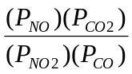
= 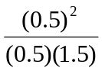
= (no units) ;

 | (vi) |  |  | From the information provided above, propose the most effective method for removing oxides of nitrogen produced by the combustion of fuel? | [1]
 |  |  |  | Catalytic scrubber/ catalytic converter.
 | (vii) |  |  | Write equations to show how CO and NO are removed by the car engines. | [2]
2NO + 2CO → 2CO₂ + N₂;
2CO + O₂→ 2 CO₂ ;
 |  |  |  | [Total: 13 marks]
2 | A 1.00g sample of steel containing manganese was dissolved in nitric acid to give a solution of manganese with an oxidation state of +2. All the manganese present was then oxidized to manganate (VII) by adding sodium bismuthate, NaBiO₃. After destruction of any excess bismuthate ion, the resulting purple solution required 36.0 cm³ of a 0.100 mol dm⁻³ iron(II) sulphate solution for complete reaction.  [5 mol. of Fe²⁺ required 1 mol. of MnO₄⁻ for complete reaction]
 | (i) |  | What is the oxidation number of bismuth in NaBiO₃? |  | [1]
 |  |  | +5
 | (ii) |  | Given that the bismuthate ion is reduced to Bi³⁺, write a reducing half equation for the reaction in which it functions like an oxidizing agent. |  | [1]
 |  |  | BiO₃⁻(aq) + 6H⁺(aq) + 2e → Bi³⁺(aq) + 3 H₂O(l)
 | (iii) |  | Hence, write a balanced equation for the oxidation of manganese (II) to manganese (VII) in an acidic solution. |  | [1]
 |  |  | 2Mn²⁺(aq) + 5 BiO₃⁻(aq) + 14H⁺(aq) → 2MnO₄⁻(aq) + 5 Bi³⁺(aq) + 7H₂O(l)
 | (iv) |  | Calculate the % by mass of manganese in the steel sample. |  | [4]
Amount of Fe²⁺ = 0.100 x 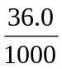
= 3.600 x 10⁻³ ;(4 sf)

Since 5Fe²⁺ ≡ MnO₄⁻

Amt of MnO₄⁻ produced = 3.60 x 10⁻³ x
= 7.200 x 10⁻⁴ mol; (4 sf)

Amt of Mn²⁺ present in steel sample = Amt of MnO₄⁻ produced
=7.200 x 10⁻⁴ mol; (4 sf)

Mass of Mn²⁺ present in sample = 7.20 x 10⁻⁴ x 54.9
= 0.03950g ; (4 sf)

% by mass = 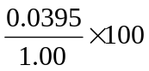= 3.95% ; (3 sf)
 |  |  | [Total: 7 marks]
3 | The use of the Data Booklet is relevant to this question.  The elements of Period 2 and 3 form some of the most common compounds that we come across.
 | (i) | Define the term ionisation energy. |  |  | [1]
 |  | Ionisation energy is the minimum amount of energy required to remove 1 mole of electrons from 1 mole of gaseous atom to form 1 mole of gaseous ion.;
 | (ii) | Describe and explain the difference in second ionisation energy of aluminium and silicon. |  |  | [2]
Electronic configuration of AI⁺: 1s² 2s² 2p⁶ 3s²
Electronic configuration of Si⁺ :1s² 2s² 2p⁶ 3s² 3p¹ ;

The second ionisation energy of Si is lower than that of Al as the electron removed is in the higher energy 3p orbital. Hence less energy is needed.;
 | (iii) | Between Li⁺ and Be⁺, state and explain which ion would be deflected the most when they are passed through an electric field? |  |  | [2]
Li⁺ will be deflected more. ; (mark is not awarded if the explanation is incorrect.)

This is because the angle of deflection is proportional to charge/ionic radius. Since Li⁺ has a smaller ionic radius, the angle of deflection will be larger.;
 | (iv) | Write balanced equations to show the reaction of chlorides of Na, Al and Si with water. State the pH of the solution formed. |  |  | [4]
NaCl(s) + aq → Na⁺(aq) + Cl⁻ (aq); pH = 7

AlCl₃ + aq → [Al(H₂O)₆]³⁺ (aq) + 3Cl⁻ (aq)
[Al(H₂O)₆]³⁺ (aq) → [Al(H₂O)₅(OH)]²⁺ (aq) + H⁺ ; pH = 3

SiCl₄ + 2 H₂O → SiO₂ + 4HCl; pH=2

; if all the pH are correct.
 |  | [Total: 9 marks]
4a | Compound A, 2-bromobutane reacts with sodium hydroxide under two different sets of reacts to give 2 different product mixtures Compound C (C₄H₁₀O) and Compound D(C₄H₈).
 | (i) | Describe the conditions necessary to form Compound C and Compound D respectively. |  |  | [2]
Compound C:
Aqueous NaOH, heat under reflux. ;

Compound D:
Alcoholic NaOH, heat under reflux. ;

 | (ii) | Using your answers from (i), describe a further test to verify that the Compound A is 2-bromobutane. |  |  | [2]
After reacting the compound with aqueous NaOH to give compound C. acidify the solution with HNO₃., Add AgNO₃(aq) to the compound. ;

The presence of a cream ppt indicates the presence of 2-bromobutane. ;
 | (iii) | Compound D is a mixture of 3 isomers. Draw the displayed formulae of the 3 isomers. |  |  | [3]
But-1-ene;
Cis-but-2-ene ;
Trans-but-2-ene ;

(All bonds must be fully shown)
 | (iv) | The use of the Data Booklet is relevant to this question.  2-chlorobutane can also react with NaOH to give compound C. Compare the rate of reaction of 2-bromobutane and 2-chlorobutane with NaOH to give Compound C.  Explain the difference in reactivity using information from the data booklet. |  |  | [2]
2-chlorobutane will react more slowly than 2-bromobutane. (mark is not awarded if the explanation is incorrect.)

The bond energy of C-Cl in 2-chlorobutane is much higher than C-Br in 2-bromobutane. Hence, it is much harder to break the bond.
(b) | Archaeologists treat wood artifacts with ethane-1,2-diol to prevent drying and preserve their quality.
 | (i) | Why is it that wood artifacts in museum must not be left to dry out? |  |  | [1]
 |  | Wood artifacts will crack and spoil if left to become too dry.;
 | (ii) | Suggest the reagents and conditions required to convert ethene to ethane-1,2-diol. |  |  | [1]
 |  | Cold dilute alkaline KMnO_{4;}
 |  | [Total: 11 marks]

SECTION B (40 MARKS)

Answer two of the three questions in this section on separate paper.

5(a) | A solution containing propanoic acid and its salt, sodium propanoate acts as a buffer solution. |  |  | [3]
 | (i) |  | What do you understand by the term buffer solution?
 |  |  | A buffer is a solution whose pH remains almost unchanged when a small amount of acids or alkalis are added to it.;
 | (ii) |  | Write ionic equations to show how this solution reacts with  I added H⁺ (aq) ions,  II added OH⁻ (aq) ions.
I: H⁺ + CH₃CH₂COO⁻ → CH₃CH₂COOH ;
II: OH⁻ + CH₃CH₂COOH → CH₃CH₂COO⁻ + H₂O ;
(b) | Propanoic acid is a monoprotic acid. A solution of 0.100 mol dm⁻³ propanoic acid has a pH of 2.94. |  |  | [5]
 | (i) |  | Explain, with the aid of appropriate calculations, whether propanoic acid is a strong or weak acid.
pH = 2.94; ∴[H⁺] = 10^{-2.94} = 1.15 x 10⁻³ mol dm⁻³
Propanoic acid is a weak acid as [H⁺] is much lower than the concentration of the Propanoic acid.

OR

[H⁺] ≠ [Propanoic acid].

 | (ii) |  | Use the data given to calculate the value of K_{a} of propanoic acid.
 |  |  | K_{a} = [H⁺]² / [HA] = (1.15 x 10⁻³)² / 0.1 = 1.32 x 10⁻⁵ mol dm⁻³
 | (iii) |  | Suggest a suitable indicator for the titration of propanoic acid with aqueous sodium hydroxide. Explain your choice.
WA-SB titration: phenolphthalein.;
The working range of the indicator corresponds to the sharp pH change of the solution at end point. ;
(c) | 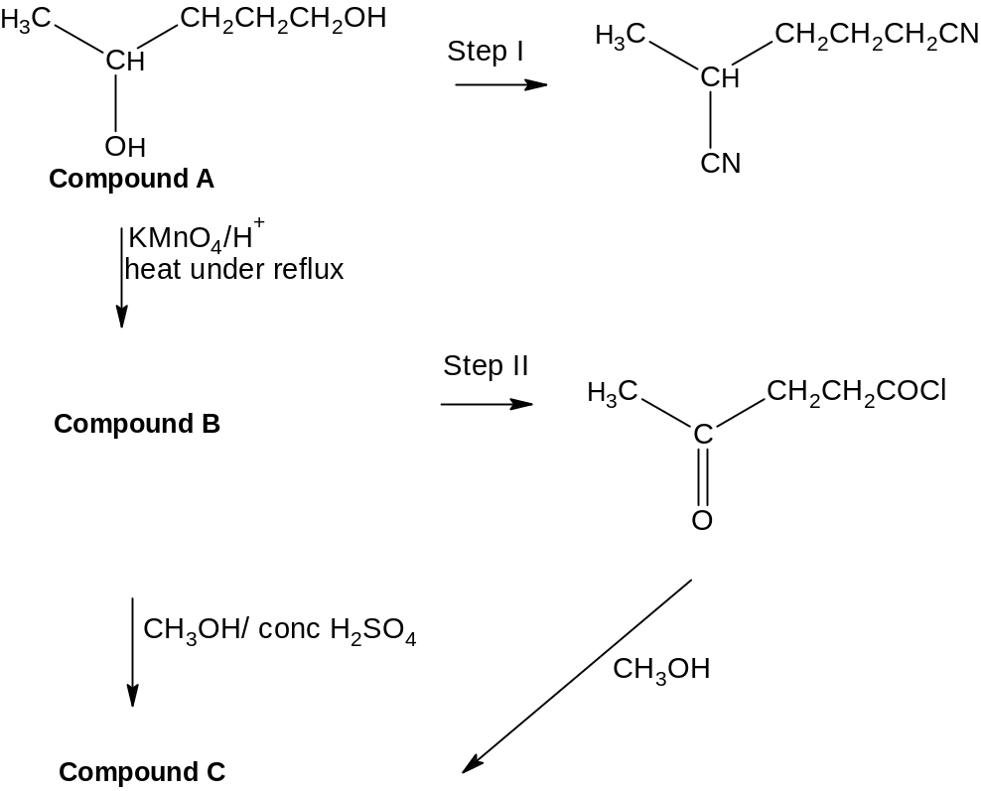 |  |  | [5]
 | 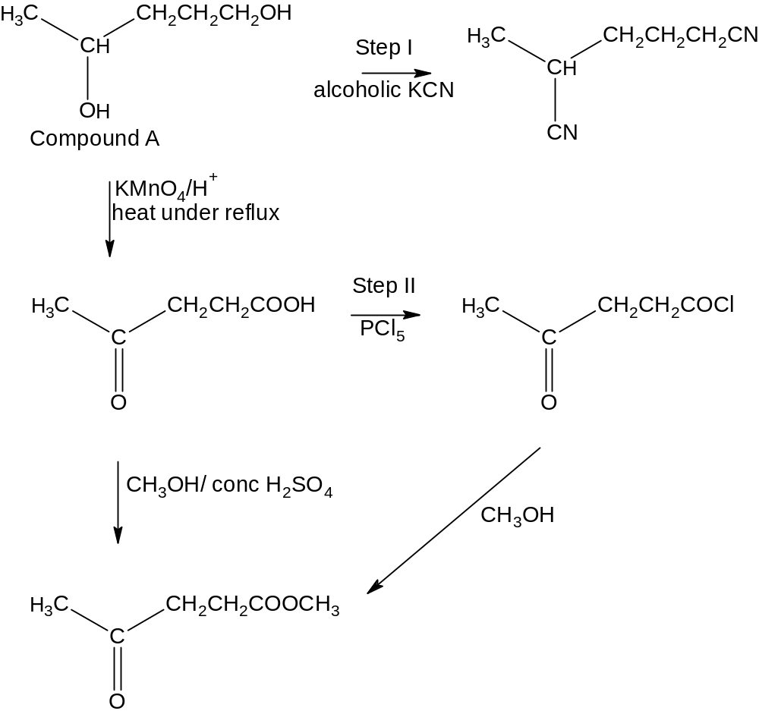
 | (i) | State the IUPAC name for compound A.
 |  | Penta-1,4-diol.
 | (ii) | State the reagents and conditions for Step I and Step II.
Step I: alcoholic KCN/ heat under reflux;
Step II: PCl₅, PCl₃, SOCl₂;
 | (iii) | Draw the structural formula of Compound B and Compound C.
Compound B: 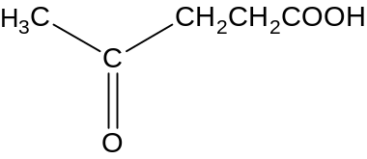

Compound C: 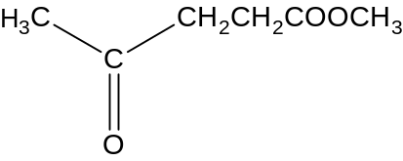
 | (iv) | State the hybridisation, shape and number of sigma and pi bonds about C_{x} and C_{y} for the following molecule.  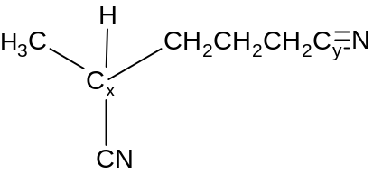 |  | [2]
C_{x}: sp³, 4 sigma ;
C_{y}; sp, 2 sigma, 2 pi ;
(d) | A student wrote the following summary in his notebook.  Atomic radius of period 2 elements increases across the period because of the increase in nuclear charge. The increase in nuclear charge is due to an increase in the number of electrons. There is negligible shielding effect across the period. Hence, the outermost electrons are more strongly attracted towards the nucleus.  Ionic radius of elements increases across the period because of the greater effective nuclear charge experienced by the outermost electron. The ionic radius of cation is greater than the atomic radius of its element because of the isotopic nature of the ion.  Identify the incorrect chemistry in his summary and substantiate your answer with correct chemistry. |  |  | [5]
Atomic radius of period 2 elements decreases across the period because of the increase in nuclear charge. ;

The increase in nuclear charge is due to an increase in the number of protons.;

There is negligible increase shielding effect across the period. Hence, the outermost electrons are more strongly attracted towards the nucleus.;

Ionic radius of elements decreases across the period because of the greater effective nuclear charge experienced by the outermost electron.

The ionic radius of cation is smaller than the atomic radius of its element because of the decrease in number of electron shells for the cation.

6(a) | The theoretical enthalpy of combustion values are given as follow:
 |  |  |  | [10]
  Fuel | Main Sources | Enthalpy of combustion/ kJ g⁻¹ | Boiling point / ºC
  Methane | Petrochemical industry | 55.6 | -161.5
  Propane | Petrochemical industry  Natural Gas | 50.3 | -42.1
  Octane | Refined from crude oil | 47.9 | 125.7
  Ethanol | Hydration of ethane  Fermentation | 29.7 | 78.3
 | (i) |  | Define the term enthalpy of combustion.
 |  |  | Enthalpy of combustion is the amount of energy released when 1 mole of a compound is burnt in excess oxygen.
 | (ii) |  | 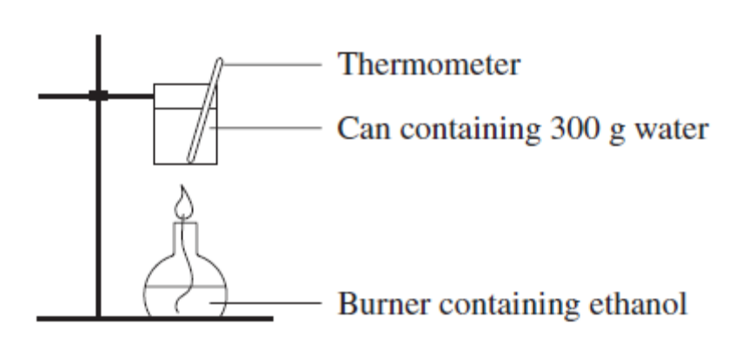
The following results were obtained.

Initial mass of burner/ g | 133.20
Final mass of burner/ g | 132.05
Initial temperature of water/ºC | 25.0
Final temperature of water/ºC | 45.5

 |  |  | Determine in the enthalpy of combustion of ethanol in kJ g⁻¹ based on the above experimental conditions. (Heat capacity of water is 4.2 JK⁻¹)
mc∆T = ∆H_{c} x n_{ethanol}
(300)(4.2)(45.4-25.0) ; = ∆H_{c} x (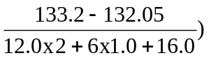;

25704 = ∆H_{c} x (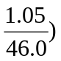;

∆H_{c}= 1126.08 kJ mol⁻¹;

= 1126.08/ (2x 12.0+5.0+ 17.0) kJ g⁻¹;
= 24.5 kJ g⁻¹;

 | (iii) |  | State 2 assumptions that you have made in your calculations for (ii)
The density of water in the can has a density of 1g cm⁻³.;

The heat efficiency of the system is 100%/ There is no heat loss to the environment/ All the heat that is produced by ethanol is transferred to the can of water.

 | (iv) |  | Explain the difference in boiling point between methane, octane and ethanol.
Ethanol has the highest boiling point because a lot of heat energy is required to overcome the stronger hydrogen bonding between the ethanol molecules.;

Both octane and methane are non-polar molecules.
Octane has a higher boiling point compared to methane because it has a larger electron cloud size due to its higher M_{r}. ;

More energy is required to overcome the stronger id-id interaction between octane molecules than methane molecules.; Since hydrogen bonding is stronger than id-id interaction, ethanol will have a higher boiling point than octane.
(b) | Ethanol is a popular starting reagent for many organic reactions.
 | (i) |  | In 2 steps, suggest the reagents and conditions needed to convert ethanol to propanoic acid. Write equations to show the formation of the intermediate. | [3]
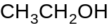 + KCN(alcoholic) → 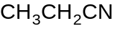 ; + KOH

Reagents: Alcoholic KCN
Conditions: Heat under reflux ;

+ 2H₂O + H⁺ → 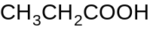 + NH₄⁺

Reagents: H₂SO₄
Conditions: Heat under reflux ;
 | (ii) |  | Compare the difference in acidity between ethanol and ethanoic acid. | [3]
- Ethanoic acid is more acidic than ethanol. ;
- The conjugate base CH₃COO⁻ for ethanoic acid is resonance stablised where the negative charge on the ion is dispersed across the 2 oxygen. Hence, ethanoic acid undergoes dissociation more easily to give H⁺ ion.;
- The CH₃CH₂O⁻ ion is destablised by the electron donating CH₃CH₂ group. Hence, ethanol undergoes dissociation less easily to give H⁺ ion.;
(c) | Describe a simple chemical test which will distinguish the following pairs of compounds from each other. You should include the reagents and conditions needed and the expected observations for each compound in your answer. |  |  | [4]
 | (i) |  | CH₃CH(OH)CH₂CH₂CH₃ and CH₃CH₂CH(OH)CH₂CH₃
Reagents/ conditions: aqueous alkaline iodine/ heat under reflux.;

Observations: CH₃CH(OH)CH₂CH₂CH₃ will give a yellow ppt of CHI₃ and an antiseptic smell while CH₃CH₂CH(OH)CH₂CH₃ will not.;
 | (ii) |  | CH₃CH₂CH=CH₂ and CH₃CH=CHCH₃
Reagents: acidified KMnO₄, heat under reflux.;

Pass the gas produced from the reaction through Ca(OH)₂.
Products from the oxidation of CH₃CH₂CH=CH₂ will give a white ppt with Ca(OH)₂ while CH₃CH=CHCH₃ will not.;
7(a) | Trichloromethane is hydrolysed by sodium hydroxide solution according to the equation shown below.  2CHC/₃ + 7OH⁻ → CO + HCO₂⁻ + 6Cl⁻ + 4H₂O  Some data was recorded in order to study the kinetics of the reaction. |  |  | [10]
   | Initial [CHCl₃]  (mol dm⁻³) | Initial [OH⁻]  (mol dm⁻³) | Initial rate  (mol dm⁻³ s⁻¹)
  I | 1.0 x 10⁻¹ | 1.2 x 10⁻¹ | 1.0 x 10⁻⁴
  II | 0.5 x 10⁻¹ | 2.4 x 10⁻¹ | 1.0 x 10⁻⁴
  III | 0.5 x10⁻¹ | 4.8 x 10⁻¹ | 2.0 x 10⁻⁴
 | (i) |  | Explain the terms order of reaction and half life.
The order of reaction (or overall order of reaction) is the sum of the orders of reaction with respect to the reactants. ;
OR
Assume Rate = k[A]^{m}[B]^{n}.
For the above rate equation, overall order of reaction = m+n.;

Half life is the time taken for the concentration of the reactants to drop to half of its original concentration.;
 | (ii) |  | Deduce the rate equation for the reaction between trichloromethane and hydroxide ions.
1st order wrt to trichloromethane. ;

1st order wrt to hydroxide ions; (Workings must be shown.)
 | (iii) |  | Calculate the initial rate of the reaction in experiment (I) at the time when half of the hydroxide ions have reacted.
[CHCl₃] left = 1.0 x 10⁻¹ – (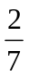)(0.5x1.2 x 10⁻¹) = 0.0829 mol dm⁻³ ;

In experiment (I)
k = 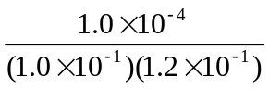= 8.33 x 10⁻³ ;

Rate = k (0.6 x 10⁻¹) ( 0.0829)
= (8.33 x 10⁻³) (0.6 x 10⁻¹) ( 0.0829) = 4.15 x 10⁻⁵ moldm⁻³s⁻¹ ;

 | (v) |  | Define catalyst and explain how the rate of the reaction will be affected when a catalyst is used. Illustrate your answer with a Boltzmann distribution diagram where appropriate.
A catalyst is a substance which increases the rate of a reaction by providing an alternative reaction path of lower activation energy, without itself undergoing any permanent chemical change.;

With the catalyst, the number of reactants with energy greater than this lowered activation energy increases as observed by the larger area under the curve. The rate of reaction increases as the frequency of collisions between these molecules increases.;

Fraction of molecules
Kinetic energy
E_{a}
Fraction of molecules with kinetic energy ≥ E_{a} for uncatalysed reaction.
E'_{a}
(Catalysed)
Fraction of molecules with kinetic energy ≥ E_{a} for catalysed reaction.

Must include legend for diagram;
(b) | Compound X has the molecular formula C₄H₆O₂. X does not dissolve in acid or alkali at room temperature. X reacts with LiAlH₄ in the presence of dry ether to give V. X reacts with hydrogen cyanide to form Y, C₆H₈O₂N₂. X also reacts with hot acidified KMnO₄ to produce Z, C₄H₆O₃.  2.50g of Z is dissolved in 250cm³ of water. 25.0cm³ of this solution is neutralized by 12.25 cm³ of an aqueous solution of 0.100 mol dm⁻³ sodium carbonate giving W, which has a high melting point.  Suggest the structural formula of V, W, X, Y and Z. Explain the chemistry involved. |  |  | [10]
X does not dissolve in acid or alkali at room temperature. | X is neutral. X is a carbonyl compound or ester.;
X reacts with LiAlH₄ in the presence of dry ether to give V. | X is a carbonyl compound which has undergone reduction.;
X reacts with hydrogen cyanide to form Y, C₆H₈O₂N₂. | X undergoes nucleophilic addition reaction with HCN to form Y.;
X also reacts with hot acidified KMnO₄ to produce Z, C₄H₆O₃. | X contains aldehyde groups which can be further oxidized to carboxylic acid.;
2.50g of Z is dissolved in 250cm³ of water. 25.0cm³ of this solution is neutralized by 12.25 cm³ of an aqueous solution of 0.100 mol dm⁻³ sodium carbonate giving W. | Amount of Z that reacted with Na₂CO₃  = 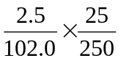= 2.45 x 10⁻³  Amt of Na₂CO₃ that reacted = 0.1 x 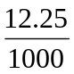= 1.225 x 10⁻³  Z: Na₂CO₃ = 2: 1  Z is a monobasic acid.;  X contains 1 aldehyde group only.;  X contains another ketone group.
W, which has a high melting point. | W is an ionic salt.;

 | Max 5 for explanations.
X:  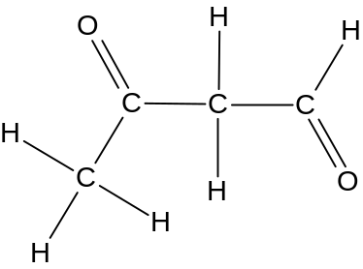 | Y: 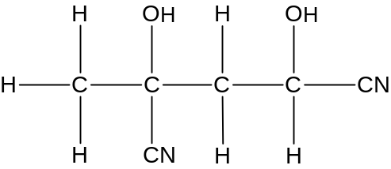
Z:  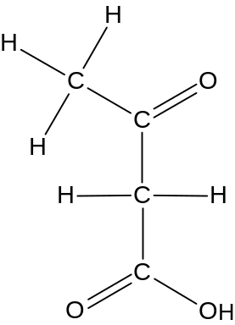 | V:  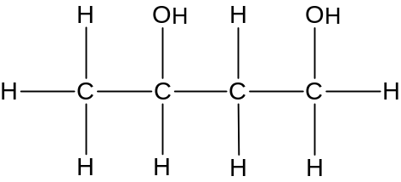
W: 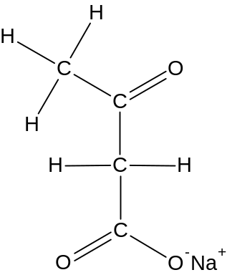.

 | * Displayed formula is not expected.

